Application Security Assessment Report
Project: Deep Learning CCTV Metal Detection System
Assessment Type: Software Composition Analysis (SCA) and Static Application Security Testing (SAST)

1. Executive Summary
A structured application security assessment was conducted on the Deep Learning CCTV Metal Detection System. The objective was to evaluate dependency related risks (SCA) and identify insecure coding patterns (SAST).
The assessment identified known vulnerabilities within a third-party dependency and minor static code issues. All identified issues were remediated.
The assessment included:
- Software Composition Analysis (SCA) using pip-audit
- Static Application Security Testing (SAST) using Bandit

Key Findings (Pre-Remediation)
- Five confirmed vulnerabilities were identified in a core third-party dependency: setuptools version 65.5.0.
- Vulnerabilities included multiple Python Security (PYSEC) advisories and CVE-2024-6345, affecting package handling and build processes.
- Two low-severity code-level issues were identified, including hardcoded credential patterns and unsafe exception handling.

Risk Exposure (Before Remediation)
- If deployed to production without remediation, the application would have faced:
- Supply chain compromise risk through outdated build tooling.
- Potential arbitrary code execution during package handling.
- Increased likelihood of malicious package injection attacks.
- Operational instability due to suppressed runtime exceptions.
- Potential compliance violations under secure development standards (e.g., OWASP ASVS, ISO 27001 A.14 secure development controls).
Although no active exploit was observed, the presence of publicly disclosed CVEs significantly increases exploit probability over time.

Business Impact (If Left Unresolved)
- Compromise of alerting mechanisms (false positives or suppressed detections).
- Integrity risk to stored detection screenshots.
- Service interruption during exploitation.
- Reputational damage if the surveillance system failed in a real-world security scenario.
- Possible breach notification obligations depending on deployment context.

2. Scope of Assessment
The following components were evaluated:
- Python source code (approximately 409 lines of code).
- Installed Python dependencies.
- Local development configuration.
Out of Scope:
- Cloud infrastructure.
- Network penetration testing.
- Production deployment environment.

3. System Overview
The application performs real-time monitoring of CCTV footage using a deep learning model to detect metallic objects. Upon detection, the system may trigger alerts (audio/email/webhook) and store screenshots for further review.
Core Components:
- Video frame capture module.
- Deep learning inference engine.
- Configuration management (JSON-based).
- Alerting subsystem.
- Local screenshot storage.

4. Software Composition Analysis (SCA)
SCA was performed using pip-audit to identify known vulnerabilities in installed Python dependencies.
Findings:
The following vulnerabilities were identified in setuptools version 65.5.0:
- PYSEC-2022-43012
- PYSEC-2025-49
- CVE-2024-6345
These vulnerabilities affect packaging and build mechanisms, potentially enabling:
- Arbitrary code execution during package processing
- Malicious package injection in compromised environments
- Build pipeline manipulation
Although this application is not a distributed package itself, exploitation within a development or CI/CD pipeline could compromise integrity of deployed artifacts.

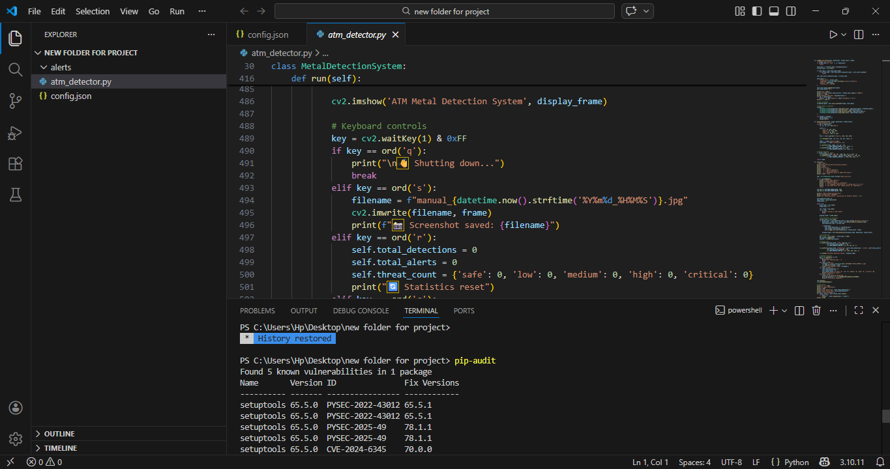

Risk Quantification
Risk was assessed based on:
- Public disclosure (CVE published)
- Availability of fixes
- Dependency criticality (core packaging system)
- Pre-remediation risk level: Medium to High (Supply Chain Exposure)
Rationale:
- Core packaging dependency
- Known CVEs
- Widely deployed component
- Attack surface increases in CI/CD or shared development environments
Remediation:
- The package was upgraded to setuptools version 78.1.1, which resolves all identified vulnerabilities.
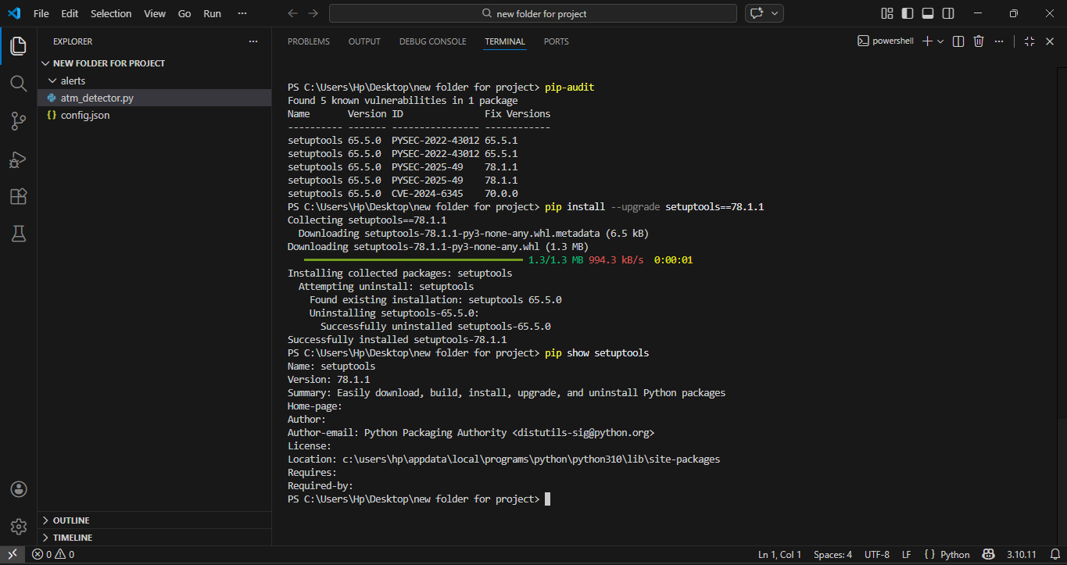
Post-Remediation Status:
- Re-running pip-audit confirmed no remaining known dependency vulnerabilities.

5. Static Application Security Testing (SAST)
SAST was performed using Bandit to identify insecure coding patterns and potential security weaknesses.

Bandit Results
Total lines of code scanned: 409
Total findings: 2 (Low severity)
High/Medium severity findings: 0

Finding 1: Hardcoded Credential Pattern
A placeholder SMTP password was defined directly in code. While not an active secret, hardcoded credentials present a risk if real values are later inserted.

Security Risk
Hardcoded credentials represent a high-risk pattern, even if the current value is non-sensitive. This creates:
- Risk of accidental credential exposure
- Increased likelihood of secret leakage via Git commits
- Credential reuse risk if developers substitute real values
- Violation of secure coding best practices (OWASP A02: Cryptographic Failures / Secret Management)

Business Impact
If deployed with a real credential:
- An attacker gaining repository access could extract SMTP credentials.
- Email systems could be abused for phishing or spam distribution.
- Alert integrity could be compromised.

Risk Assessment
- Likelihood (if left unresolved): Medium
- Impact (if real credential inserted): High
- Overall Pre-Remediation Risk: Medium
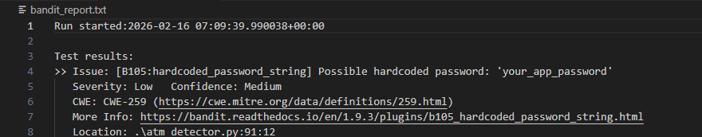
Remediation:
- Replaced hardcoded password usage with environment variable retrieval (e.g., os.getenv('SMTP_PASSWORD')).
Finding 2: Bare Exception Handling
A broad 'except: pass' statement was identified, which may suppress critical runtime errors.
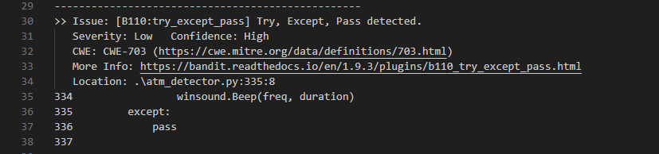

Security Risk
Bare exception handling introduces:
- Silent failure conditions
- Loss of error visibility
- Debugging difficulty
- Potential masking of security-relevant runtime events
In a surveillance system context:
- Detection failures could go unnoticed.
- Alert mechanisms may fail silently.
- False sense of operational reliability.

Business Impact
If this occurred in production:
- Missed metal detection events.
- Failure to trigger alerts.
- Reputational damage due to undetected threats.
- Operational downtime without traceability.

Risk Assessment
- Likelihood: Medium
- Impact: Medium
- Overall Pre-Remediation Risk: Low to Medium
Remediation:
- Replaced with structured exception handling and logging to preserve error visibility.

